Phase II: User Requirements and Application Specifications

Submission Deadline: 18.03.2024, 23:59

**1. Chosen Development Model: Agile**

Justification: Agile development was chosen for the product development, focusing on simplicity

and customer involvement. This method allows for continuous feedback from customers,

prioritizing their requirements and evaluating system iterations. It aims to deliver working

software quickly, evolving rapidly to meet changing needs, and eliminates complexity through an

iterative approach that interleaves specification, design, implementation, and testing. Outputs

are decided through negotiation during the development process.

**2. User Requirements:**

**a. Stakeholders:**

End-Users (Students): They are the primary users of the Studental platform. Their role is

crucial as they will be actively using the platform to search for and apply to internships,

scholarship, employment, and training opportunities. The application process will be conducted

on the client's website or application through specific links provided. This feature aims to

enhance the simplicity of the Studental website and improve the accuracy of the registration

or application process. Their interests lie in having a user-friendly interface, comprehensive

information about opportunities divided in categories and accessibility features.

Clients (Employers and Organizations): These stakeholders offer opportunities on the

platform. Their interests include reaching a targeted audience of students, showcasing their

opportunities effectively, and receiving applications. Their role involves listing their

opportunities accurately, providing necessary details, and engaging with potential candidates through their websites\applications and HR. They send these details to the application manager, who is me. This allows me to double-check the provided opportunities, selecting suitable ones and excluding those that do not apply to Albanian students.

Developer\Administrator: As the sole developer building the Studental platform with Wordpress, my responsibility is to create and maintain the website. My role includes translating user requirements into functional features, ensuring technical functionality and security, and continuously improving the platform based on feedback. My interest lies in delivering a high-quality, scalable, and efficient website that meets user needs and aligns with (my) business goals.

Other Relevant Parties: This may include university officials, industry partners, regulatory

bodies, and funding agencies. Their roles and interests can vary but may involve endorsing the

platform, providing resources or support, ensuring compliance with regulations, or contributing

to the platform's sustainability and growth.

**b. User Stories:**

**Present a few detailed user stories:**

Administrator Stories:

○ The administrator can view/ edit/ delete/add the opportunities.

○ An administrator has access to every component of the website.

End-User (Student) Stories:

○ A student can select the category of the opportunity he is most interested in or the company.

○A student can scroll on all the opportunities available without any filter if he/she wants to have a look.

○ A student must register/create an account in order to save the opportunities that he is interested in.

○If the student wants to apply, the details of the opportunity and the application will be shown but the website will not serve as an intermediary for the application process.

**3. Functional Requirements:**

**a. Brief Description:**

Functional Requirements:

○User Registration

Service Provided: Allows users to create accounts on the platform.

Input Reaction: Upon receiving user registration details, the system should validate and store

the information securely.

Behavior in Situations: The system should prevent duplicate accounts and notify users of any

registration errors.

○Category Navigation

Service Provided: Enables users to navigate through different categories.

Input Reaction: When a user selects a category, the system should display relevant opportunities under that category.

Behavior in Situations: If a category has no opportunities or is empty, the system should provide

a message indicating no available opportunities.

○Opportunity Listings:

Service Provided: Displays a list of available opportunities.

Input Reaction: The system should fetch and display opportunities based on user-selected

categories or filters.

Behavior in Situations: If there are no opportunities listed under a category, the system should

notify the user that no opportunities match their criteria.

○Opportunity Details:

Service Provided: Presents detailed information about each opportunity.

Input Reaction: When a user clicks on an opportunity, the system should display its description,

requirements, and other relevant details.

Behavior in Situations: If an opportunity's details are missing or incomplete, the missing information should be blank and the user can contact the company itself offering the opportunity for more detailed/ missing information.

○Administrator Access:

Service Provided: Grants admin privileges to upload, edit, and maintain opportunities.

Input Reaction: Admins can add new opportunities, modify existing ones, and ensure the

accuracy of information.

Behavior in Situations: The system should track admin actions.

○User Login:

Service Provided: Allows users to log in to save opportunities for later.

Input Reaction: Upon successful login, the system should authenticate the user and provide

access to save opportunities.

Behavior in Situations: If login credentials are incorrect, the system should notify the user and

prevent access to saving opportunities.

**b. Acceptance Criteria:**

User can successfully register an account.

Categories are navigable and display all relevant opportunities.

Opportunities are correctly listed under their respective categories.

Company profiles show logos and links to opportunities.

Detailed information (description, requirements) is available for each opportunity.

Filtering options (by type or company) work accurately.

Admin can upload, edit, and delete opportunities as needed.

User login functionality allows users to save opportunities.

-When creating an event , the admin must include all of the following in order for an opportunity to be valid and posted on the website :

○ Title

○ Description

○ Image

○ Entity offering it

○ Deadline of application

○ Link to apply

-When rating their experience with an opportunity , students have to rate the event only on a scale from 1 to 5 stars where 1 star is the lowest and 5 stars being the highest.

-The feedback comment given from the students should be no more than 270 characters .

**4. Non-Functional Requirements:**

**a. Brief Description:**

Non-Functional Requirements:

*1.Performance:*

Constraint: System should be fast and responsive.

Goal: Response time for actions should be under 2 seconds.

*2.Usability:*

Constraint: Platform should be easy to navigate and use.

Goal: Intuitive user interface with clear navigation and instructions.

*3.Reliability:*

Constraint: System should operate consistently without errors.

Goal: System uptime should be 95% or higher.

*4.Security:*

Constraint: User data should be protected and secure.

Goal: Secure authentication mechanisms are implemented.

*5.Scalability:*

Constraint: Platform should handle a growing number of users and data.

Goal: System performance remains consistent with increasing user load.

*6.Compatibility:*

Constraint: System should work seamlessly across devices and browsers.

Goal: Compatibility with major browsers (Chrome, Firefox, Safari) and devices (desktop, mobile)

is verified.

**b. Acceptance Criteria:**

Response time for actions should be under 2 seconds.

Intuitive user interface with clear navigation and instructions.

System should operate without crashes or major errors.

User data should be encrypted and secured.

Platform should handle increased user load without significant performance issues.

Accessibility features (keyboard navigation, screen reader compatibility) are

implemented.

Compatibility with major browsers and devices is verified.

**5. Application Specifications:**

**a. Architecture:**

1. WordPress Core: Central system managing content and basic functionality.
2. WordPress Theme: Front-end presentation layer.
3. Custom Post Types and Taxonomies: Structuring content beyond default posts and pages.
4. WordPress Plugins:: Extend functionality beyond core features.
5. Database Considerations: Data storage and retrieval.
6. Performance and Security: Optimizing performance and ensuring data security.

**b. Database Model:** (made with Draw.io)

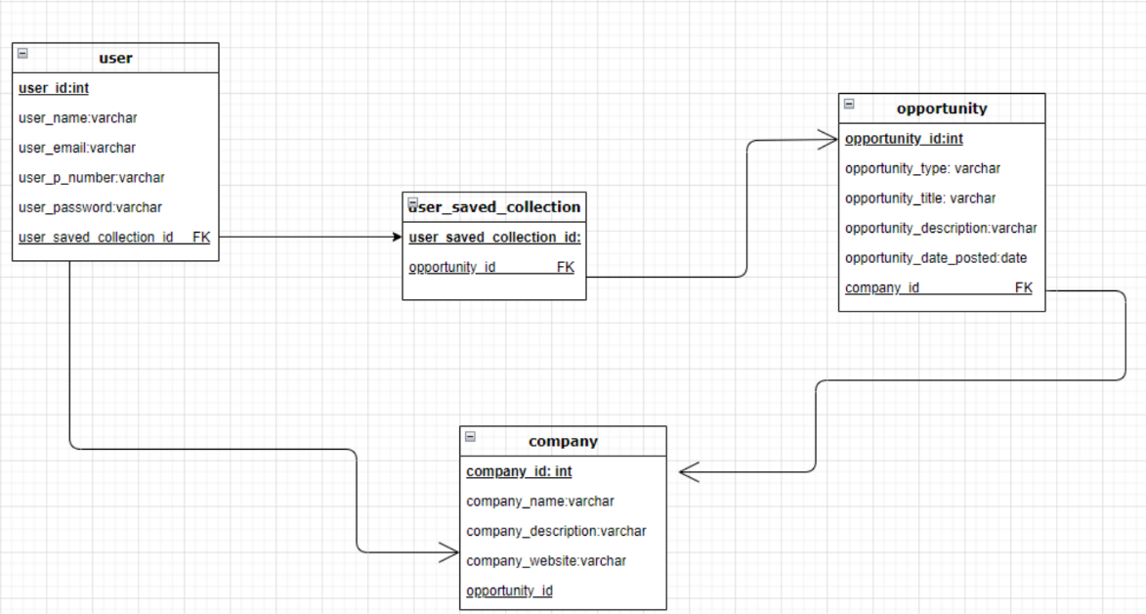

●Each student is identified by “user_id” which is the Primary Key of the table ‘user’. The name, surname, email, phone number and password are used for the registration of the student/ opening the account. The “user_email” and “user_password” data are reused every time the student wants to log-in. Each user will also possess a ‘user_saved_collection_id’ which will consist of a list with all the opportunities that the student has saved to view later to distinguish between others.

●Each ‘user_saved_collection_id’ will have none/ one/ more than one opportunity which will be identified by their ‘opportunity_id’ (it is a foreign key for this table).

●The ‘opportunity’ table will have its type, title, description, date_posted and the ‘company_id’ (Foreign Key) and the Primary Key will be ‘opportunity_id’.

●The ‘company’ table will have its name, description and their website link. The ‘opportunity_id’ will be a Foreign Key for this table as it directs to the opportunity that will be of this company.

**c. Technologies Used:**

●Wordpress, PHP.

These technologies were chosen for their seamless integration, real-time capabilities, scalability,

and developer-friendly features.

**d. User Interface Design:**

Brand Guideline of StudentAl:

https://drive.google.com/file/d/1DkmQg2IF7VbKSinsBCxYsXmLRLcEJwkU/view?usp=sharing

Below are wireframes showcasing the user interface design of our mobile application:

Login Screen:

Opportunities List:

Opportunity Details:

The user interface focuses on simplicity, intuitive navigation, and clear presentation of

information to enhance user experience.

e. Security Measures:

Our application implements robust security measures:

● Encryption: User data is encrypted both in transit (using HTTPS) and at rest .

● Authentication: It is used for secure user authentication, including